Chapter 3 Living systems
Extra worksheet 2: Blood vessels
Science understanding Verbal/Linguistic, Visual/Spatial
The heart pumps blood around the body in the circulatory system. In the circulatory system are three types of blood vessels. They each have a different structure that is related to their function.

Arteries
Arteries carry blood away from the heart. In the arteries, the blood is under high pressure from the heart beat. As seen in Figure 3.2.1, the walls of the arteries are strong, thick and elastic to withstand the pressure. Large arteries branch into smaller and smaller arteries, which spread and carry blood to all parts of the body. Eventually the branches of the arteries become very fine, and are known as capillaries.

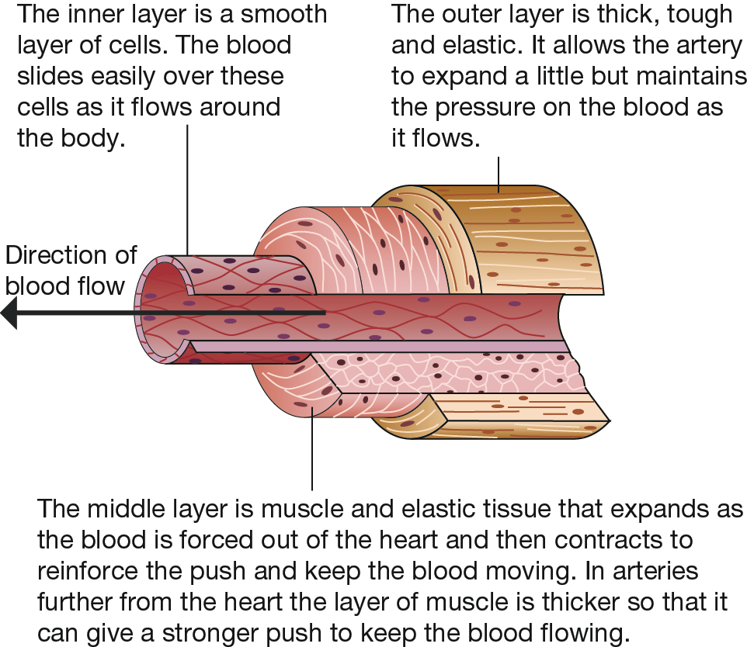
Figure 3.2.1 Structure of a an artery

Capillaries
Capillaries are the smallest blood vessels. Capillaries are so small that red blood cells can only just squeeze through them. The walls are similar to the innermost layer of the arteries, as seen in Figure 3.2.2.
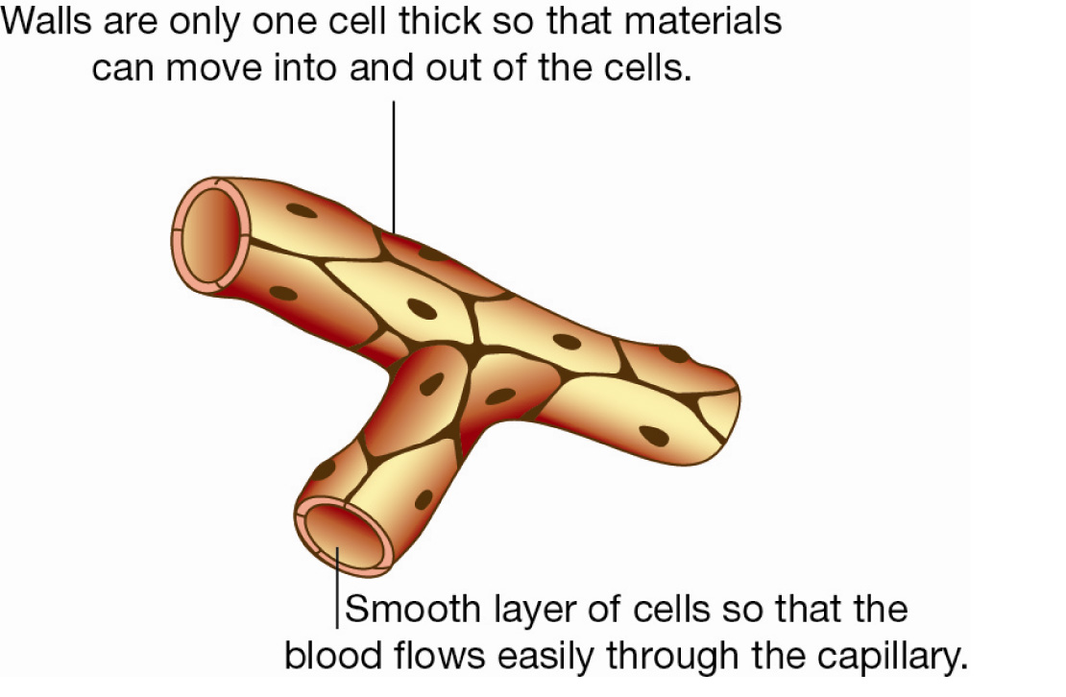
Figure 3.2.2 Structure of a capillary
The flow of blood in the capillaries is fairly slow (about 1 mm per second) and by this stage the blood is not under pressure. The capillaries reach nearly every cell of the body. The capillaries then join together forming larger vessels called veins.

Veins
Veins carry blood back towards the heart. The blood is no longer under pressure and it is moving against gravity. The structure of a vein can be seen in Figure 3.2.3.
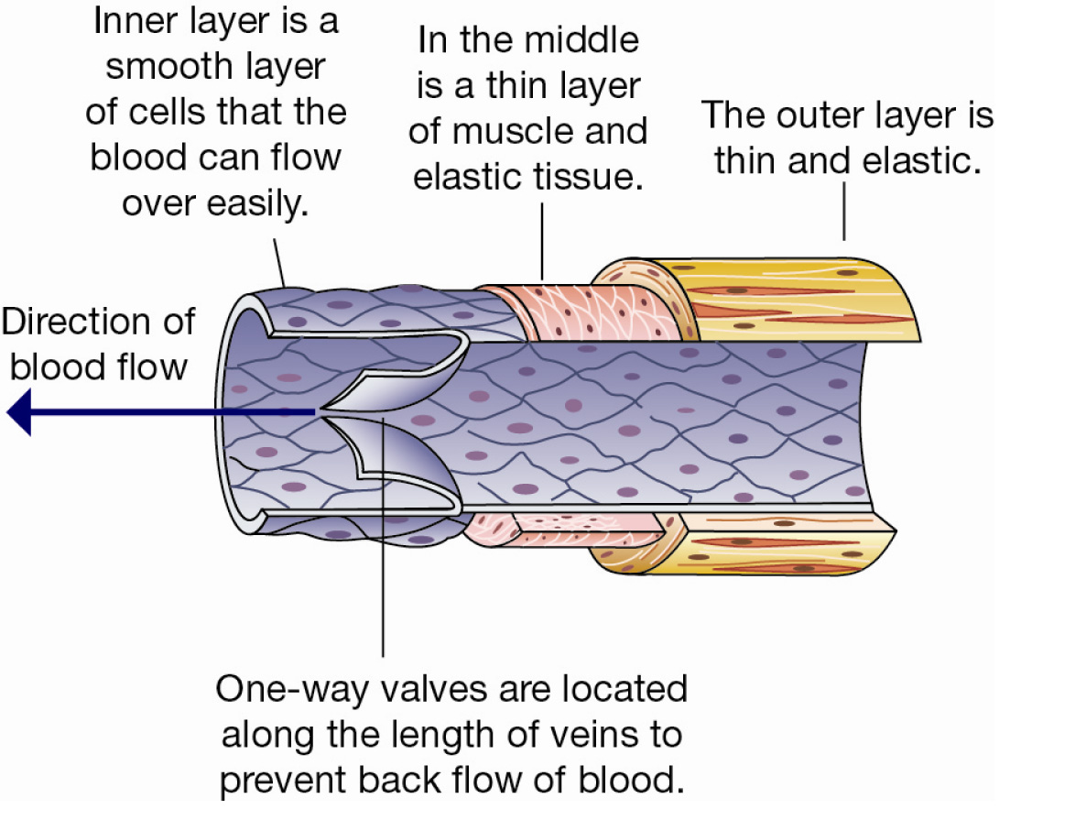
Figure 3.2.3 Structure of a vein

Questions
1 Use the names of the types of blood vessels to complete these sentences.
a Blood flows through three types of blood vessels as it circulates around the body. These are known as _______________, _______________ and _______________
b ________________ carry blood away from the heart.
c ________________ carry blood towards the heart.
d It is at the _______________ that materials are exchanged with cells.

2 Contrast arteries and veins.

3 Identify ways in which all three types of blood vessels are similar.

4 Identify ways in which all three types of blood vessels are different.

Figure 3.2.4 is a diagram of the valves in a vein. They are open, pushed against the walls as the blood flows through.
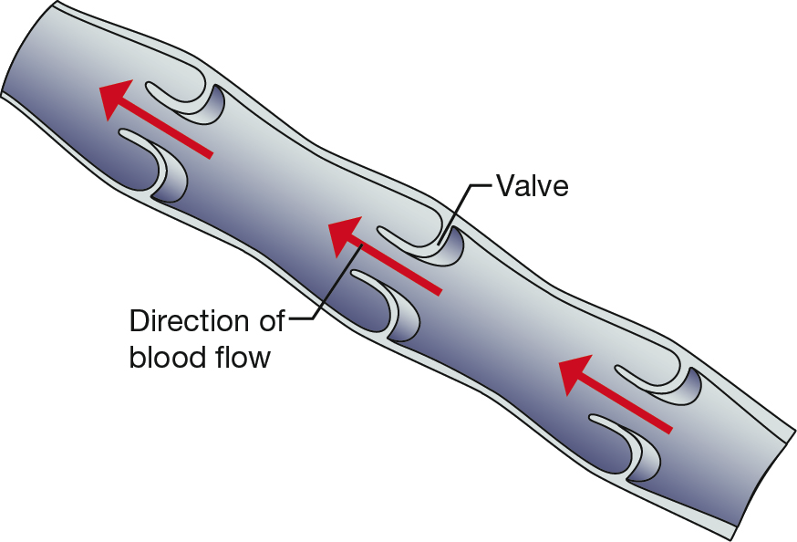
Figure 3.2.4
5 Construct a similar picture showing what happens to the valves if the blood tries to flow backwards.

6 Predict what could happen if:
a artery walls were not thick and elastic

b veins did not have valves

c capillaries had tough elastic walls

